You can change your working hours in Microsoft Teams by adjusting your settings in Outlook. Here’s how you can do it:
Using Outlook on the Web:
- Open Outlook: Go to Outlook on the web. (https://outlook.office.com/mail/)
- Access Settings: Click on the Settings gear icon in the top right corner.

- Calendar Settings: Navigate to Calendar > Work hours and location.
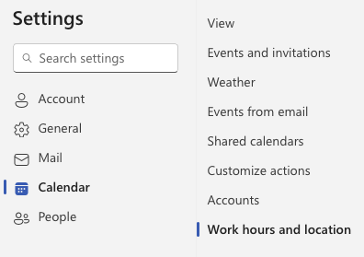
- Set Work Hours: Adjust your work hours and days according to your preference.
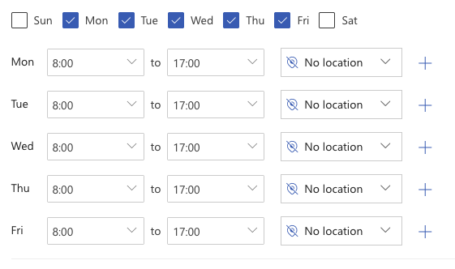
- Save Changes: Click Save.

Sync Changes:
- Restart Teams: Fully quit and restart the Teams desktop app to ensure the changes take effect. This might take some time to sync across all devices.
Additional Tips:
- Ensure Consistency: Make sure your Outlook desktop app is set to the same hours, especially if you use multiple devices.
- Manual Status: You can manually set your status in Teams to reflect your availability outside of these hours.

